**STEP-I-INTERNSHIP -TASK-2 (SQL)**

**DHRUVI PATEL**

1. **Create a table named ‘matches’ with appropriate data types for columns**

CREATE TABLE IPL_MATCH (

ID NUMBER(7),

CITY VARCHAR2(18),

M_DATE DATE,

PLAYER_OF_MATCH VARCHAR2(18),

VENUE VARCHAR2(18),

NEUTRAL_VENUE VARCHAR2(18),

TEAM1 VARCHAR2(35),

TEAM2 VARCHAR2(35),

TOSS_WINNER VARCHAR2(35),

TOSS_DECISION VARCHAR2(35),

WINNER VARCHAR2(35),

RESULT VARCHAR2(15),

RESULT_MARGIN NUMBER(5),

ELIMINATOE VARCHAR2(35),

UMPIRE1 VARCHAR2(35),

UMPIRE2 VARCHAR2(35)

);

1. **Create a table named ‘deliveries’ with appropriate data types for columns**

CREATE TABLE DELIVERIES(

INNING NUMBER(7),

M_DATE DATE,

OVER NUMBER(3),

BALL NUMBER(3),

BATSMAN VARCHAR2(18),

NON_STRIKER VARCHAR2(18),

BOWLER VARCHAR2(18),

BATSMAN_RUNS NUMBER(7),

EXTRA_RUNS NUMBER(7),

TOTAL_RUNS NUMBER(7),

ISWICKET VARCHAR2(25),

DISMISSAL_KIND VARCHAR2(15),

PLAYER_DISMISSED VARCHAR2(18),

FIELDER VARCHAR2(18),

EXTRAS_TYPE VARCHAR2(18),

BATTING_TEAM VARCHAR2(35),

BOWLING_TEAM VARCHAR2(35)

);

**3 . Import data from CSV file ’IPL_matches.csv’ attached in resources to ‘matches’**

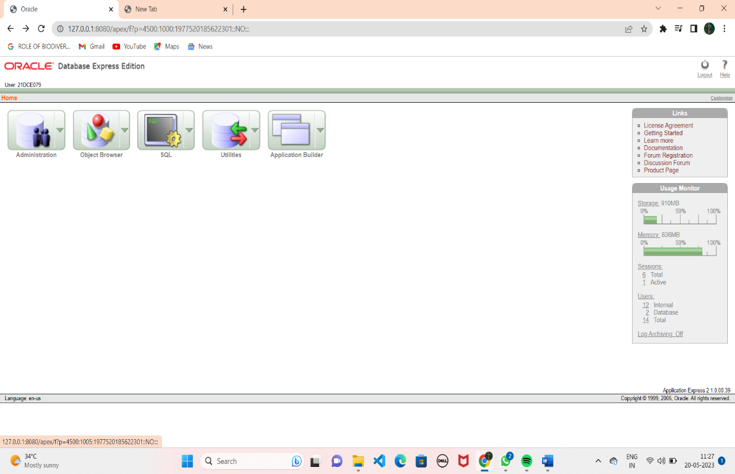

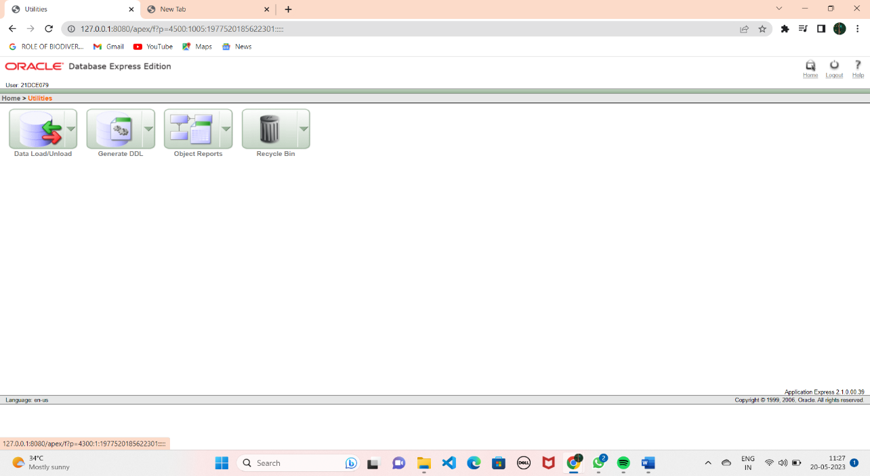

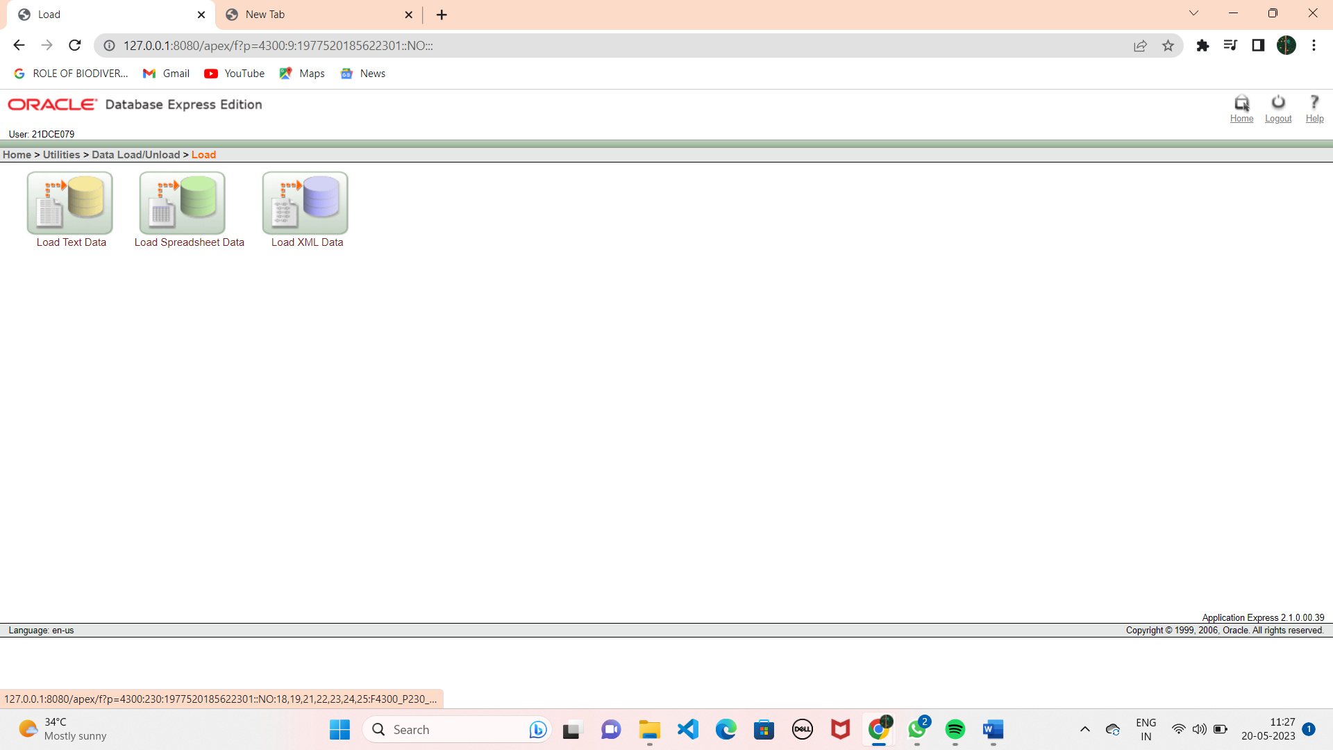

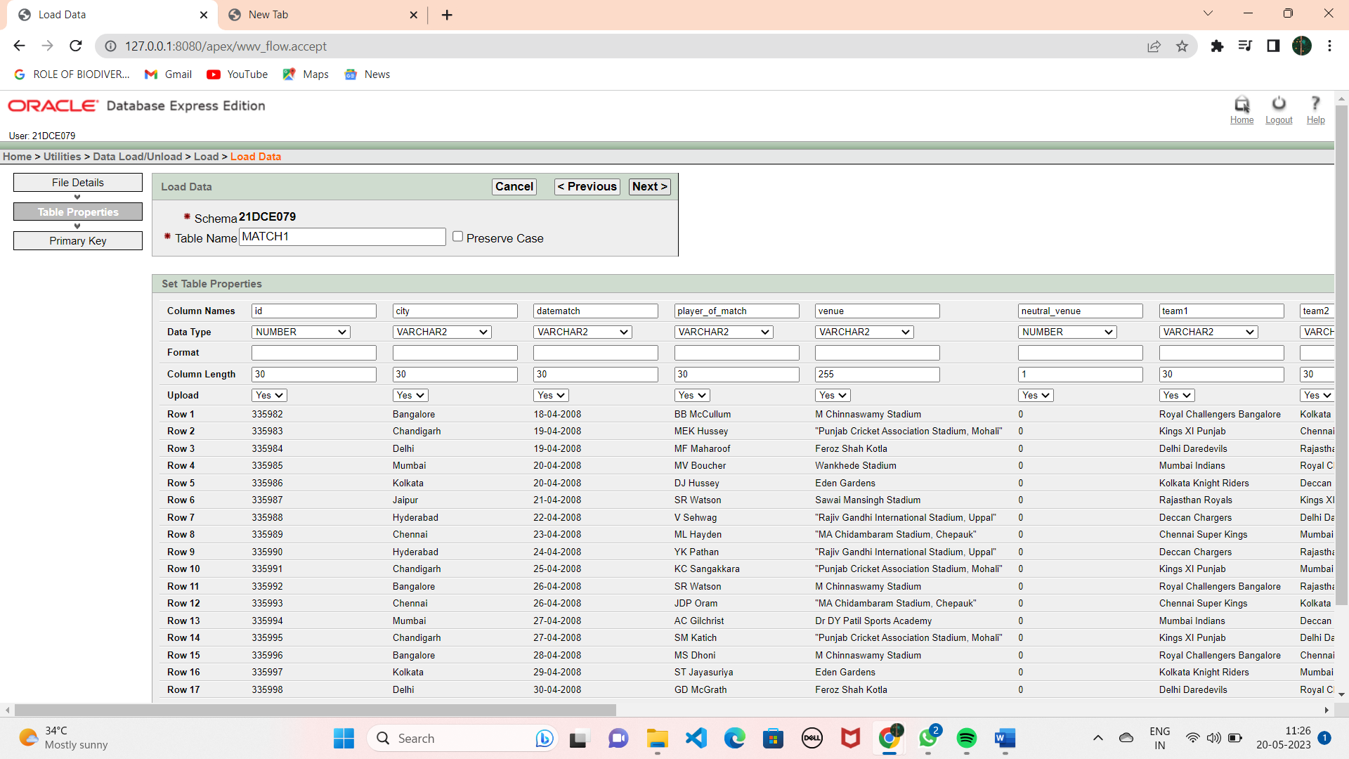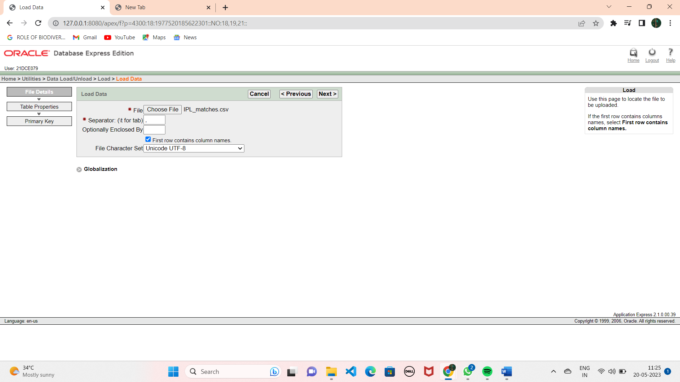

**4.Import data from CSV file ’IPL_Ball.csv’ attached in resources to**

**‘deliveries’.**

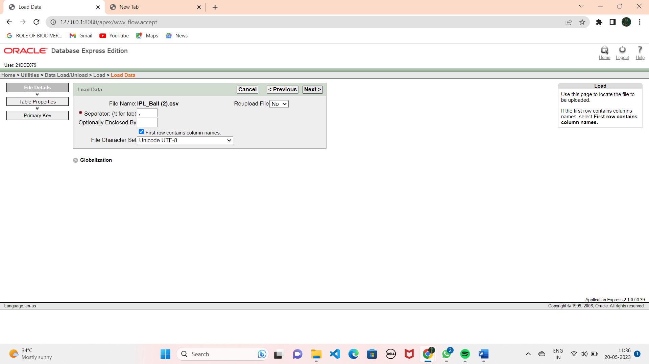

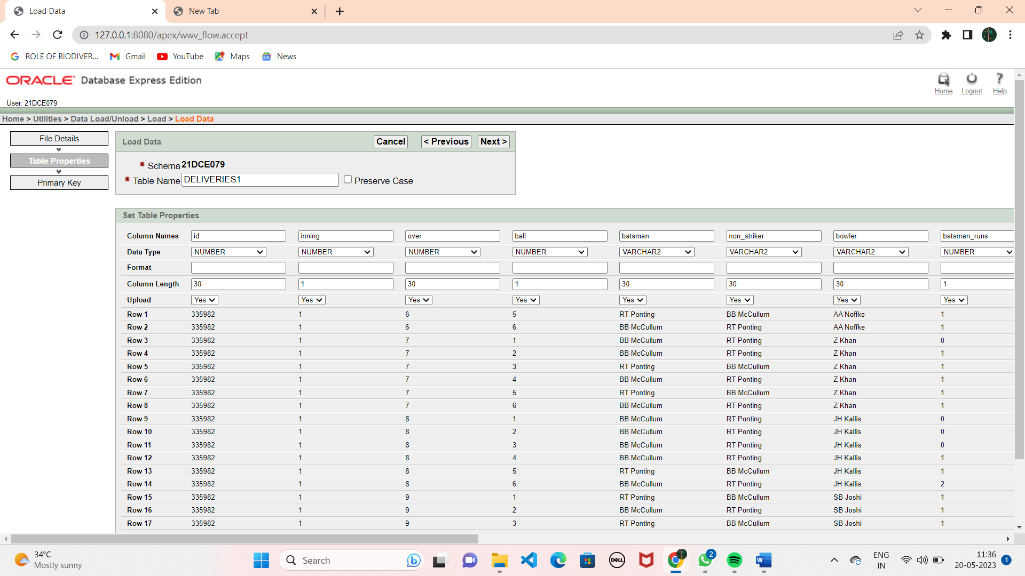

**5. Select the top 20 rows of the deliveries table.**

SELECT * FROM DELIVERIES LIMIT 20;

**6. Select the top 20 rows of the matches table**

SELECT * FROM MATCHES LIMIT 20;

**7. Fetch data of all the matches played on 2nd May 2013.**

SELECT * FROM MATCHES WHERE DATEMATCH='02-05-2013';

**8. Fetch data of all the matches where the margin of victory is more**  SELECT * FROM MATCHES WHERE RESULT_MARGIN>100;

**9. Fetch data of all the matches where the final scores of both teams are tied and order it in descending order of the date.**

SELECT * FROM MATCHES WHERE RESULT=’TIE’ ORDER BY DATE DESC;

**10. Get the count of cities that have hosted an IPL match.**

SELECT COUNT(DISTINCT CITY) FROM MATCHES;